SCHOOL BUS SERVICE NOTICE

Monday, 20th February 2023

Attention students, parents & carers,

RE: 2023 STUDENT BUS PASS

Students must collect their 2023 Bus Pass before 28th February 2022 to avoid having to complete a new application.

2022 Student Bus Passes will not be accepted for travel from 1st March 2023.

If you need assistance or have any questions, please do not hesitate to contact our team.

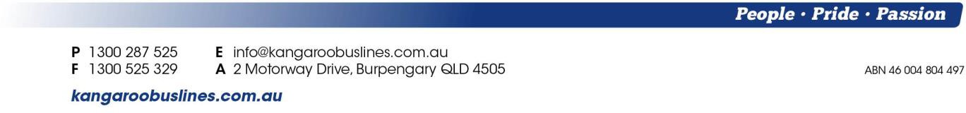
Kind Regards,
Kangaroo Bus Lines team

